Arduino Program Analysis

1. This program, at a high level, lets the user control which light pin turns on and which don’t as well as how bright each light pin is.
2. Section 1 defines where all the LED Pins are located on the Arduino Board. In this code, redPin is at D3, greenPin is at D5 and bluePin is at D6.

Section 2 is the setup. It declares the data rate in bits/second for serial data transmission and how each LED Pin behaves. In this code the pins are giving currents to the other circuits and the data rate is 9600 bits/second.

Section 3 is first part of the loop. It looks for the next valid integer in the incoming serial stream.

Section 4 is part of the loop. It tells the board the range of brightness the LED Pins should be at.

Section 5 is also part of the loop. An analog value (PWM wave) is given to the pin.

Section 6 is the last part of the loop. It prints data to the serial port as human-readable ASCII text. HEX refers to the hexadecimal format.

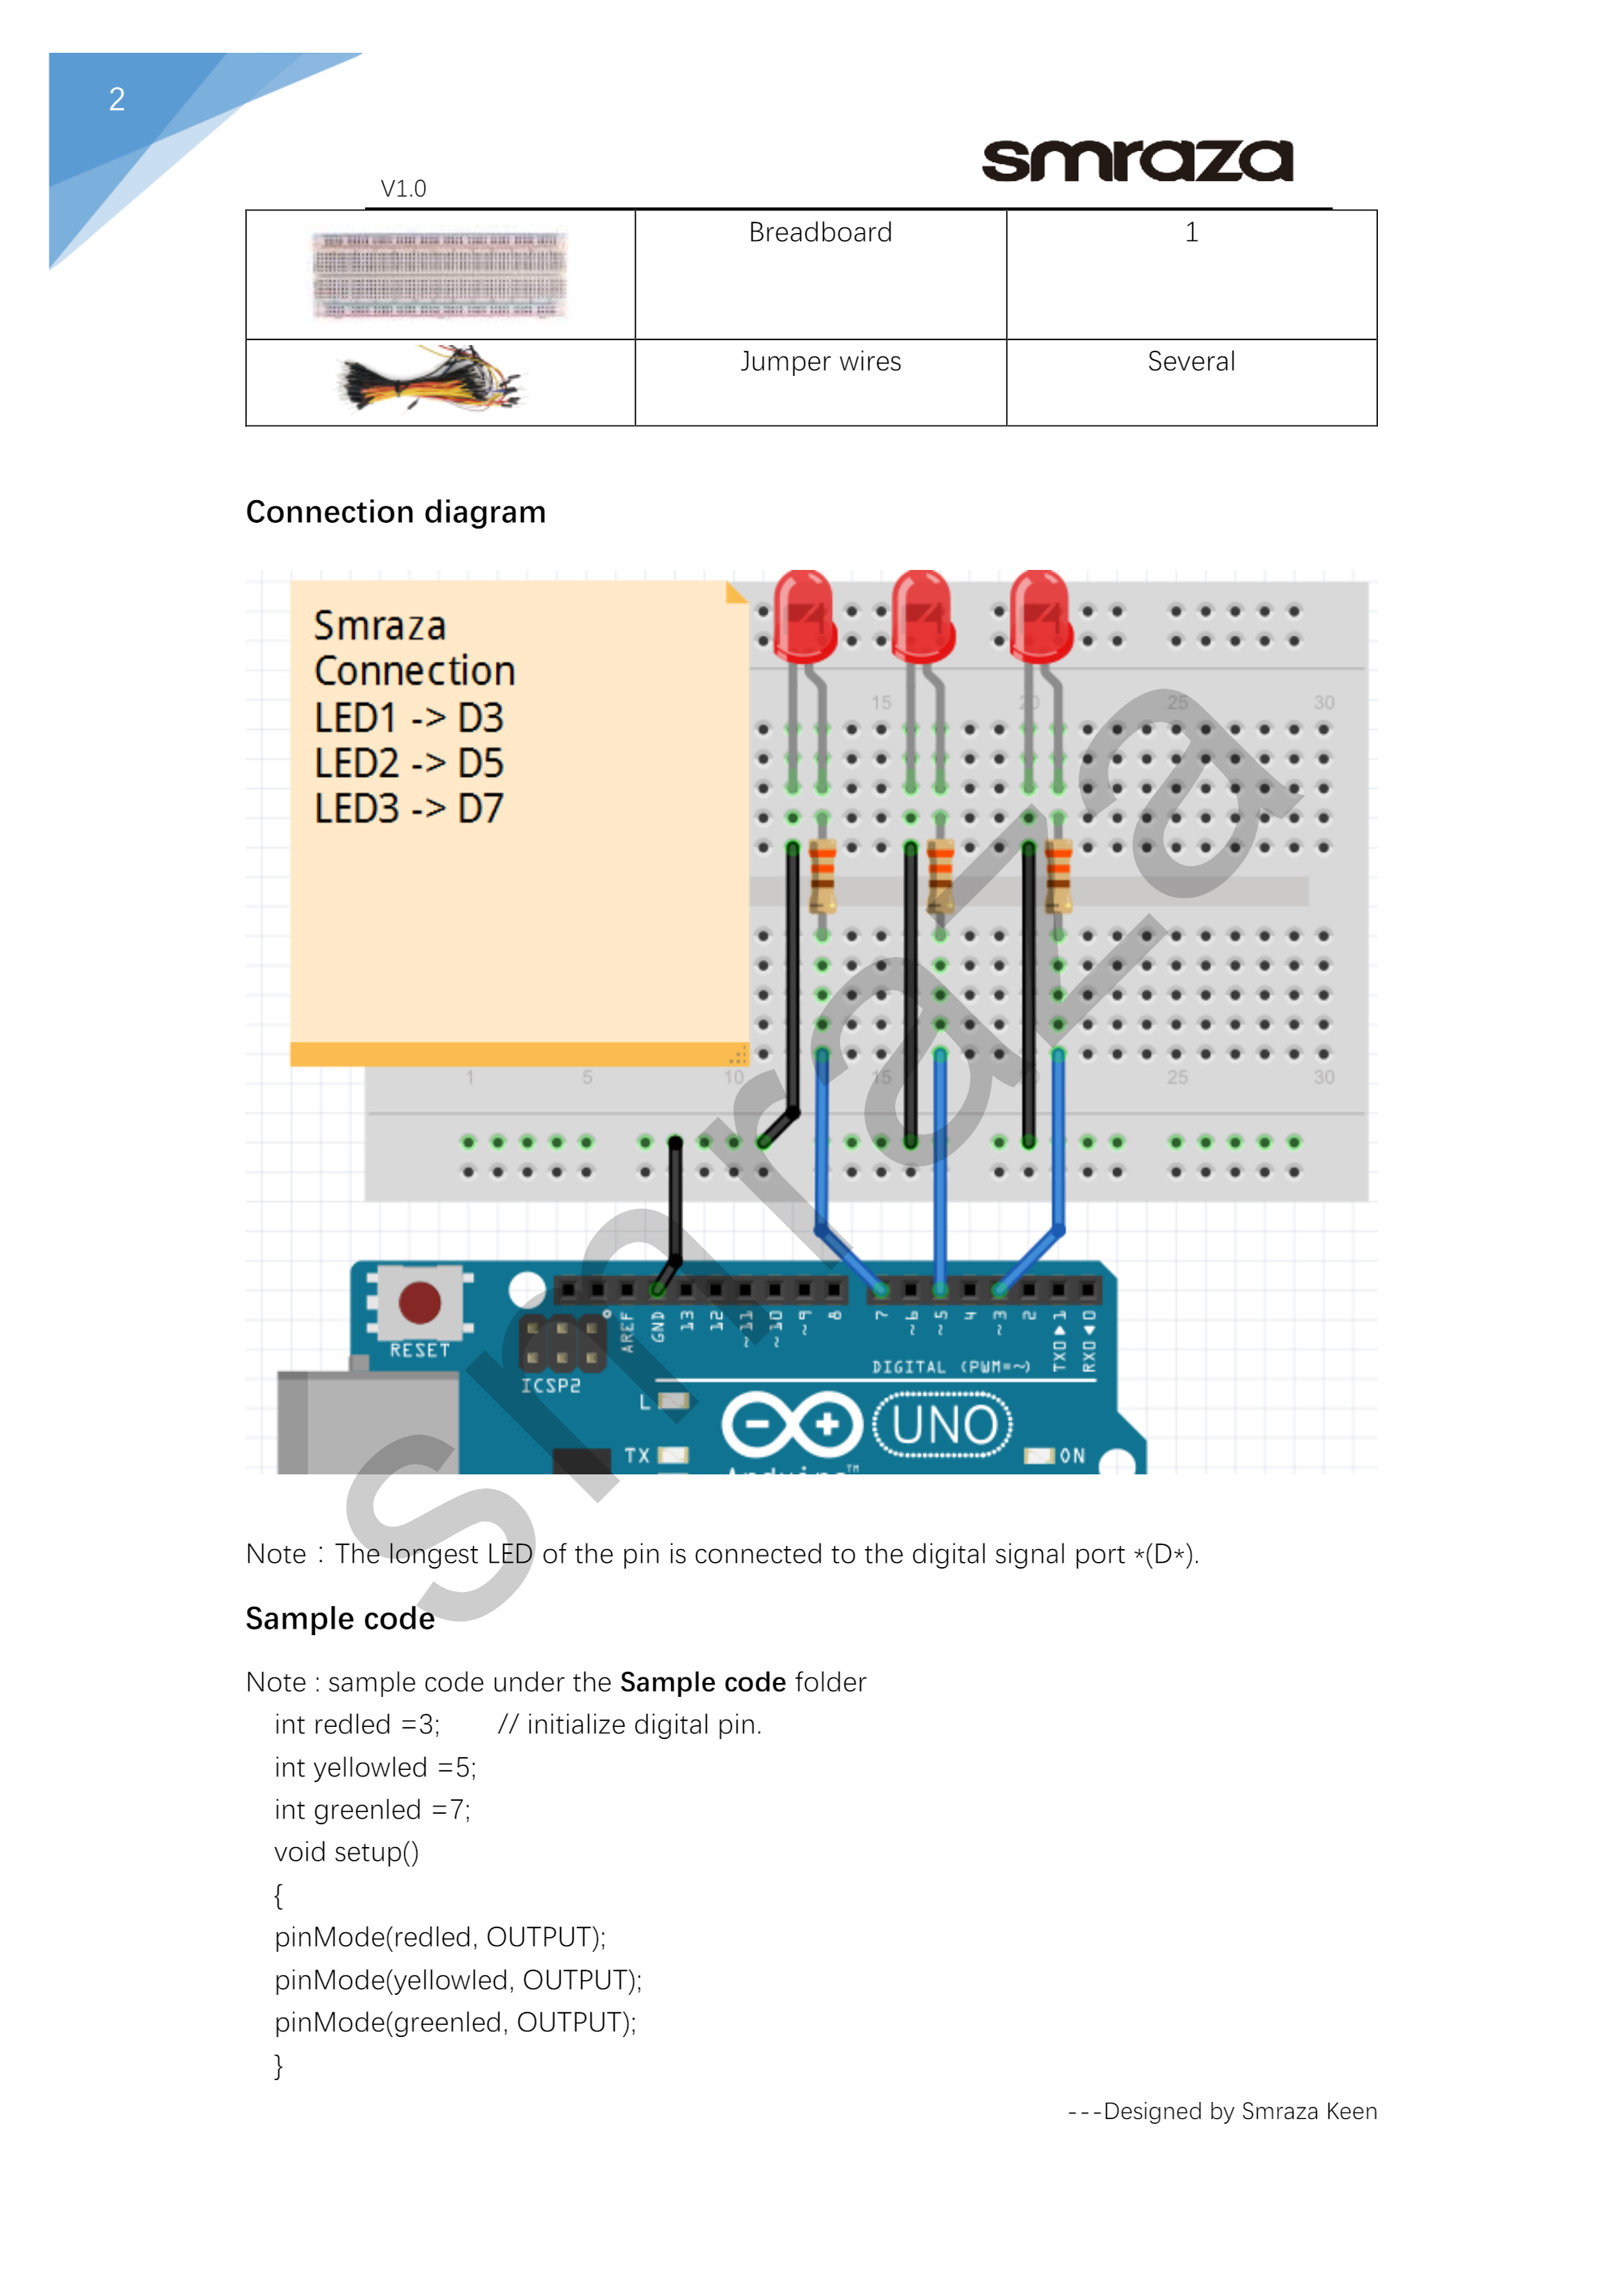

D6

*The setup would be the same except for LED3. That pin will all move down one space.

|  |  |
| --- | --- |
| Object | Meaning |
| Red Light | The program makes the red pin light fade from dark to bright |
| Blue Light | The program makes the blue pin light fade from dark to bright |
| Green Light | The program makes the green pin light fade from dark to bright |

|  |  |
| --- | --- |
| Object | Action |
| red | Tells the program to fade the red light form dark to bright |
| blue | Tells the program to fade the blue light from dark to bright |
| green | Tells the program to fade the green light from dark to bright |

1. An example of console input that would cause the program not to work properly would typing in a number. In the serial console, the only inputs that will work properly would be red, blue and green. If a number is placed, then nothing would happen to the program.